THE ONLY REQUIREMENT FOR MEMBERSHIP IS A DESIRE TO STOP USING.

Sunday: New Life Group
7:00 pm (o, ns, nv, w)
1010 N Brush College Rd

Monday: Chapter 8 Group
7:00 pm (o, ns, nv, w)
Oasis Day Center
243 W. Cerro Gordo St.

Tuesday: Survival
7:00pm (o, ns, nv, w)
1010 N Brush College Rd

Wednesday: I Found a Home Group
7:00pm (o, ns, nv, w)
Fairview Park

Thursday: Survival
7:00pm (o, ns, nv, w)
1010 N Brush College Rd

Friday TGIF Group
7:00pm (o, ns, nv, w) Oasis Day Center
243 W. Cerro Gordo St.

Saturday: We Do Recover Group 8:00pm (o, ns, nv, w)
1010 N Brush College Rd
(TEMP CLOSED

(o) – Open Meetings are for anyone wishing to experience our fellowship.
(c) – Closed meetings are only for addicts or those who think they may have a drug problem
(ns) - Non-Smoking
(w) - Wheelchair Accessible
(nv) – No Vaping

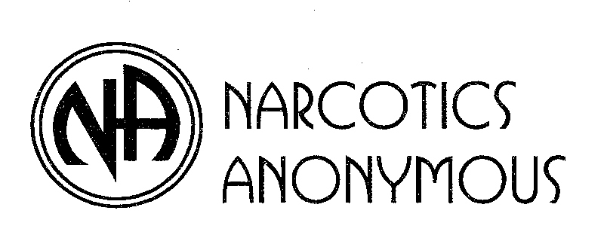

P. O. Box 3214, Decatur, IL 62524
1-800-539-0475
www.oopsna.org

mailto:info@oopsna.org

Narcotics Anonymous is not
Affiliated with any of the facilities
Where our meetings are held.

- Masks are allowed and recommended but not required.
- Meetings may be held OUTSIDE during summer months

Just for Today
Living the Program

Tell Yourself:

JUST FOR TODAY my thoughts will be on my recovery, living and enjoying life with out the use of drugs.

JUST FOR TODAY I will have faith in someone in N.A. who believes in me and wants to help me in my recovery.

JUST FOR TODAY I will have a program, I will try to follow it to the best of my ability.

JUST FOR TODAY through N.A. I will try to get a better prospective on my life.

JUST FOR TODAY I will be unafraid, my thoughts will be on my new associations, people who are not using and who have found a new way of life. So long as I follow that way I have nothing to fear.

Other Meetings:

The Twelve Steps of
Narcotics Anonymous

1. We admitted that we were powerless over our addiction, that our lives had become unmanageable.
2. We came to believe that a power greater than ourselves could restore us to sanity.
3. We made a decision to turn our will and our lives over to the care of God as we understood Him.
4. We made a searching and fearless moral inventory of ourselves.
5. We admitted to God, to ourselves and another human being the exact nature of our wrongs.
6. We were entirely ready to have God remove these defects of character.
7. We Humbly asked Him to remove our shortcomings.
8. We made a list of all the persons we had harmed, and became willing to make amends to them all.
9. We made direct amends to such people wherever possible, except when to do so would injure them or others.
10. We continued to take personal inventory and when we where wrong promptly admitted it.
11. We sought through prayer and meditation to improve our conscious contact with God, as we understood Him, praying only for knowledge of His will for us and the power to carry that out.
12. Having had a spiritual awakening as a result of these steps, we tried to carry this message to addicts, and to practice these principles in all our affairs.

Notes and Phone Numbers

For more information, 1-800-539-0475
March 1, 2023

ONLY ONE PROMISE AREA
OF
NARCOTICS ANONYMOUS

MEETING SCHEDULE

N.A. is a fellowship of recovering addicts who meet regularly to help each other stay clean. You can recover.

“N.A. offers only one promise and that is freedom from active addiction.” there is a spiritual program of recovery available today for all addicts. We no longer have to suffer and die without hope.

Decatur, Illinois

P.O. Box 3214
Decatur, IL. 62524
1-800-539-0475
www.oopsna.org

